BCI based hand exoskeleton for neurorehabilitation of stroke patients
Patients suffering from loss of hand functions caused by stroke or spinal cord injuries have driven a surge in the development of wearable assistive devices. It is known that stroke sufferers can gain much enhanced upper limb movement recovery with active physical practice (PP) in conjunction with motor imagery (MI) practice of activities of daily living. To this end, the talk will present aspects of (a) design of two-finger and three-finger exoskeletons for rehabilitation of stroke patients, (b) brain computer interface (BCI) for control and enhanced brain-limb connection facilitating neural plasticity and (c) results of clinical trials on stroke patients. The exoskeleton designs are based on the human finger motion trajectory, in order to emulate the motion of the varying instantaneous axis of rotation of the finger joints. The two-finger exoskeletons are capable of simple grasping while the three-finger exoskeletons are capable of fine object manipulation, like translation and rotation of small objects. A novel BCI that uses a fusion of EMG and EEG signals is used for controlling the exoskeleton and it provides visual neurofeedback to ensure focused physical and mental imagery practices during therapy. The PP stage is mediated by a force sensor feedback based assist-as-needed control strategy, whereas the MI practice stage provides BCI based multimodal neurofeedback combining anthropomorphic visual feedback and proprioceptive feedback of the impaired hand extension attempt. A 6 week long clinical trial was conducted on 8 hemiparetic stroke patients with a left-hand disability in India and the UK. A positive rehabilitative outcome was found for all the patients.

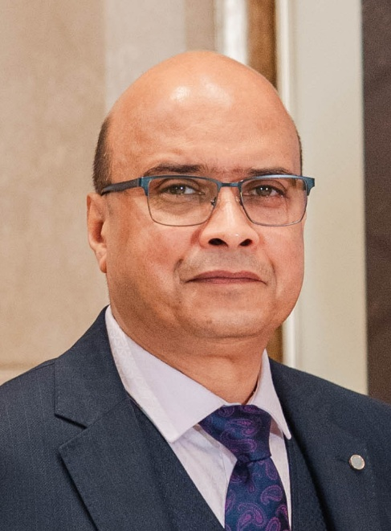

Brief bio-data:
Prof. Ashish Dutta obtained his PhD in Systems Engineering from Akita University, Japan, M.Tech from Jadavpur University and B.Tech from NIT Calicut. From 1994 to 2000 he was with the Bhabha Atomic Research Center where he worked on tele-manipulator design and control for nuclear applications. Since 2002, he is with the department of mechanical engineering at IIT Kanpur, India, as a Professor (HAG), Head of the Department (2023 – 2026) and institute Dean of Digital Infrastructure and Planning (2020 -2023). He was also a visiting professor in Nagoya University, Japan in 2006 and is currently a visiting professor at Kyushu Institute of Technology, Japan (2015 - ). His research interests are in the areas of humanoid robotics, intelligent control systems and rehabilitation engineering. Prof. Dutta has served as advisory board member of ISRO Chandrayan II Lunar mission (2009), ISRO Gagaanyan manned mission 2020, member of Task force on AI of the Ministry of Commerce and Industry (2017), Vice-President of The Robotics Society of India (2023 - ), member Bureau of Indian Standards (Robotics Section), Chairman India-South Korea robotics working group (2013-) , Chairman IEEE Robotics and Automation section (UP, UK section), etc.

